THE UNIVERSITY OF CHICAGO
COVID-19 Vendor Access Form
Complete the Initial COVID-19 Vendor Access Form
Make sure ALL employees who come on campus have been trained on the Requirements for Working in University Buildings and Attestation summarized below.
- You and all employees/sub-contractors will self-monitor for symptoms and stay home if you have potentially been exposed to COVID-19 or have had any symptoms over the past 10 days, including: cough, runny or stuffy nose, shortness of breath, fever, difficulty breathing, chills, body aches, sore throat, new loss of taste or smell, nausea, vomiting or diarrhea.
- If You or any employees/sub-contractors begin to feel sick while working at the University site, such person will leave immediately and notify Your University Sponsor. You will notify Your University Sponsor if You or any Other Vendor Agent is symptomatic or tests positive for COVID-19 in the 2 days after Your visit by contacting them.
- You and all Other Vendor Agents will wear a face covering over the nose and the mouth in University buildings and on the campus grounds when others are present.
- You and all Other Vendor Agents will follow all posted signs regarding occupancy density and all other building use and safety requirements.
- You and all Other Vendor Agents will maintain 6 feet of physical distance from others where possible.
- You and any Other Vendor Agents will sign-in/log into any spaces requiring sign-in prior to entry.
- You will also keep a log of all rooms You and any Other Vendor Agents enter in the Vendor Access Log below.
- You will provide this completed log to Your University Sponsor at the end of each day you are on site, or as otherwise directed by Your University Sponsor.
- You and Other Vendor Agents will clean and sanitize each area in which You or such Other Vendor Agents worked prior to leaving that area. Your University Sponsor will provide recommendations for cleaning materials.
- You and any Other Vendor Agents will comply with relevant federal, state or local requirements.

Each day you work on site use the Vendor Daily Access Log to check-in at the start of your shift and check-out at the end of the shift.
The on-site Primary Representative can use the hyperlinked texted or scan the QR Code with the camera on their smart phone to scan and access the forms.
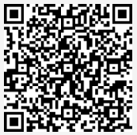
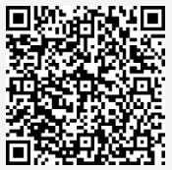
Initial COVID-19 Vendor Access Form
Vendor Daily Access Log

