Registration for UChicago Medicine Global Health Executive Training 2018

Personal Information
First Name |  | Last Name
Company Name |  | Department
Position/Title |  | Country
Phone |  | Fax
Email
Mailing Address

Payment Information | Early Registration  (by Mar 31, 2018) | Regular Registration  (after March 31, 2018)
Standard Program (3 days) | $2,000 | $2,500
Extended Program (5 days) | $3,200 | $4,000
 | Payment Total | $___________________

- The tuition includes lunch, refreshment breaks, bus transportation between hotel and the classroom, a welcome reception, a networking dinner and course materials.
- The early registration should be completed by March 31st, 2018.
- The regular registration should be completed by May 31st, 2018.
- Cancellation Policy: If you cancel your participation in this program, your registration fee, less $150.00 administrative fee, will be refunded when written notification is received by June 10, 2018. No refunds will be issued after June 10, 2018.
- To pay by credit card, please fill the form below
Card Type | Name on Card | Card Number | CVV | Expiration Date
- To pay by wire-transfer, please remit the tuition to:
University of Chicago Medical Center
Bank of America
100 West 33rd Street, New York, NY 10001
ABA Routing Number 0260-0959-3
Account Number 5800682030
Swift Code: BOFAUS3N

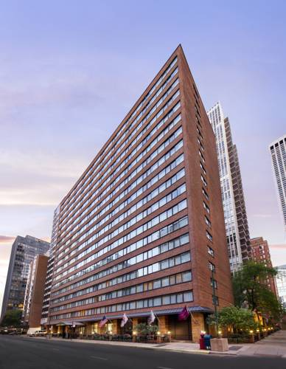
Hotel Information
We have reserved a block of rooms at Residence Inn Chicago Downtown / Magnificent Mile. Located in the posh Gold Coast district surrounded by upscale shopping and dining, the hotel suites provide a fully equipped kitchen, pullout sofa, and spacious work area with complimentary high-speed Internet access.
http://www.marriott.com/hotels/travel/chird-residence-inn-chicago-downtown-magnificent-mile/
- Address: 201 E Walton Pl, Chicago, IL 60611
- Daily Room Rate (Rates do not include applicable state and local taxes. This rate is subject to change.)
  - $219 for studio suite
  - $274 for two bedroom suite
- Complimentary breakfast and high-speed internet included.
- We will provide shuttle bus service between the hotel and the training venue.
- To reserve a room at Residence Inn Chicago Downtown / Magnificent Mile, please fill the form below.
Hotel Name | Residence Inn Chicago Downtown / Magnificent Mile | Room Type | - Studio  - Two Bedroom
Check-in date (dd/mm) |  | Check-out date (dd/mm)
Number of Guests
Special Request

Contact Information
Please complete the form and send it to:
James Bae
Regional Manager of International Programs
UChicago Medicine
+1-224-315-3948
Youngjoo.Bae@uchospitals.edu

